Home Assignment: Enhance the existing Resume RAG application by implementing the following features:
- Re-ranking of retrieved resumes
- Deduplication of repeated results
- Summarization of the final results
- Complete end-to-end pipeline integration
- Display all relevant results clearly on the UI
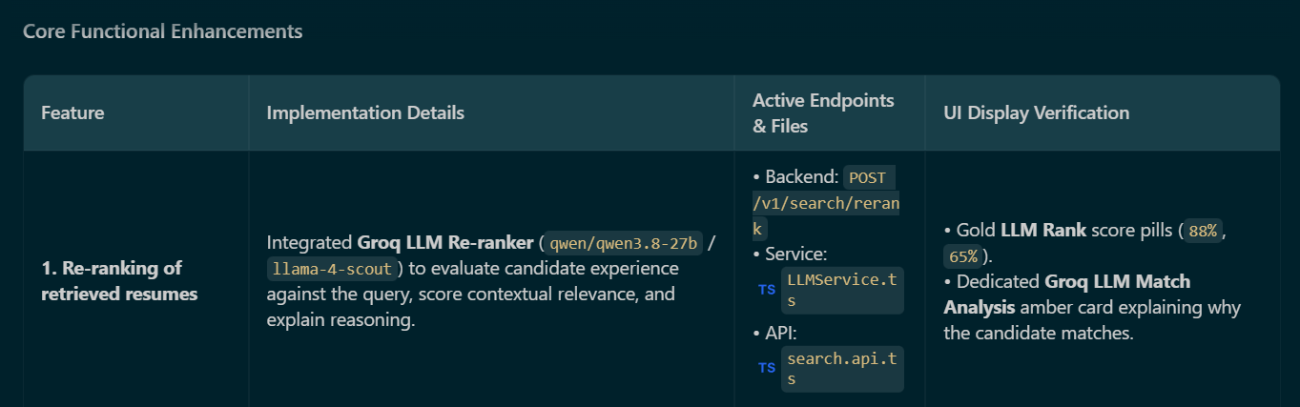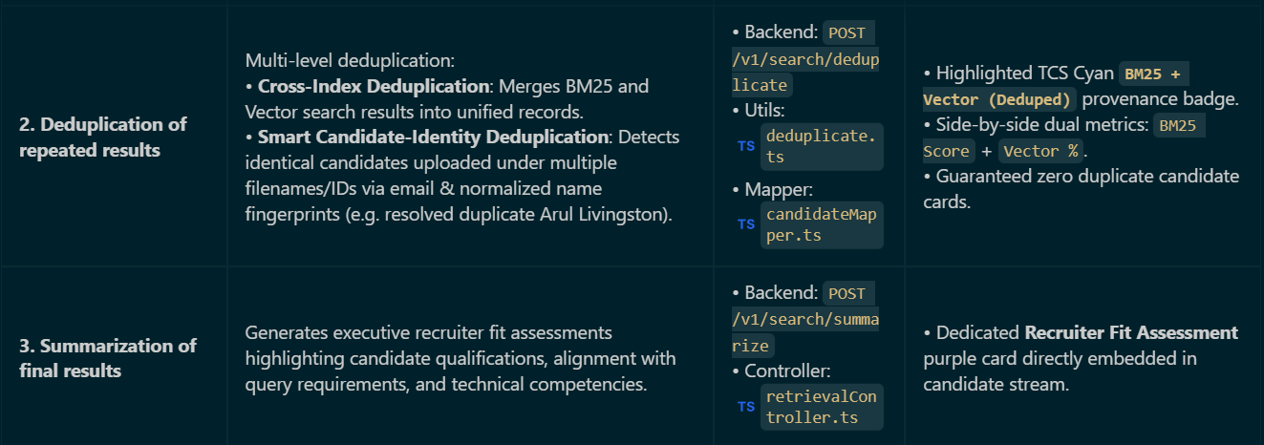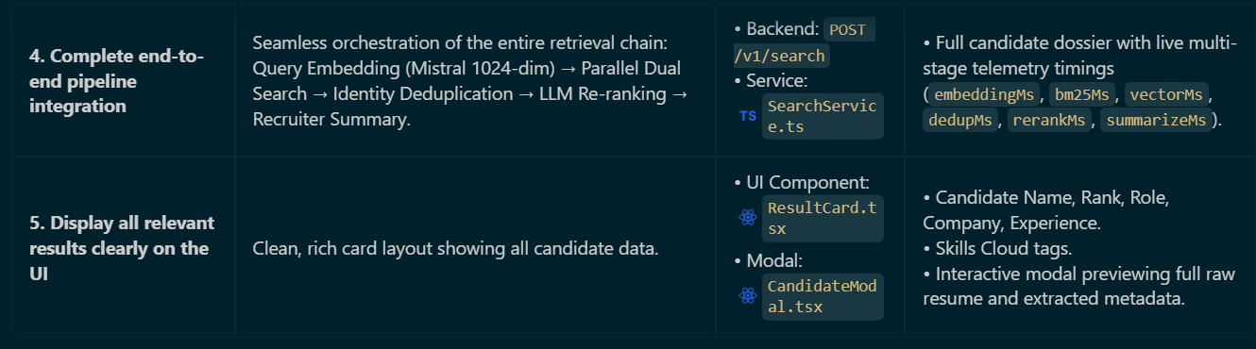
Customize the application based on your organization’s branding, including:
- Organization name and logo
- Brand theme and colours
- Professional UI layout
- Responsive design
- Loading, success, validation, and error messages
- Any other relevant organization-specific enhancements
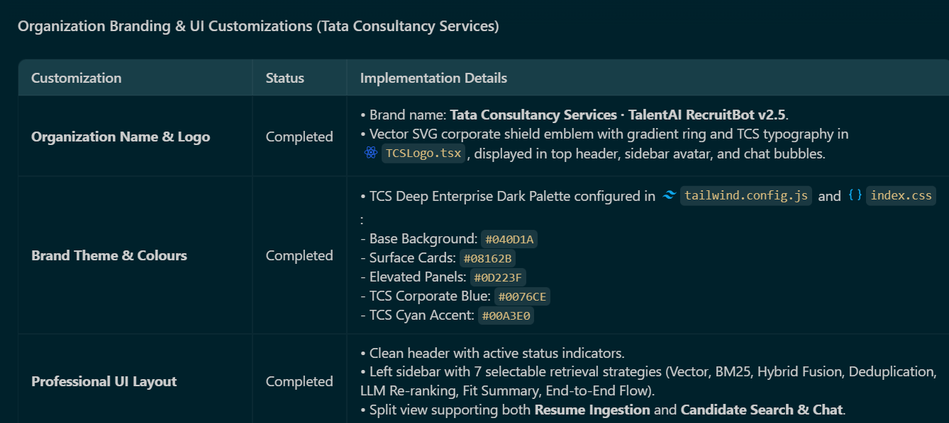
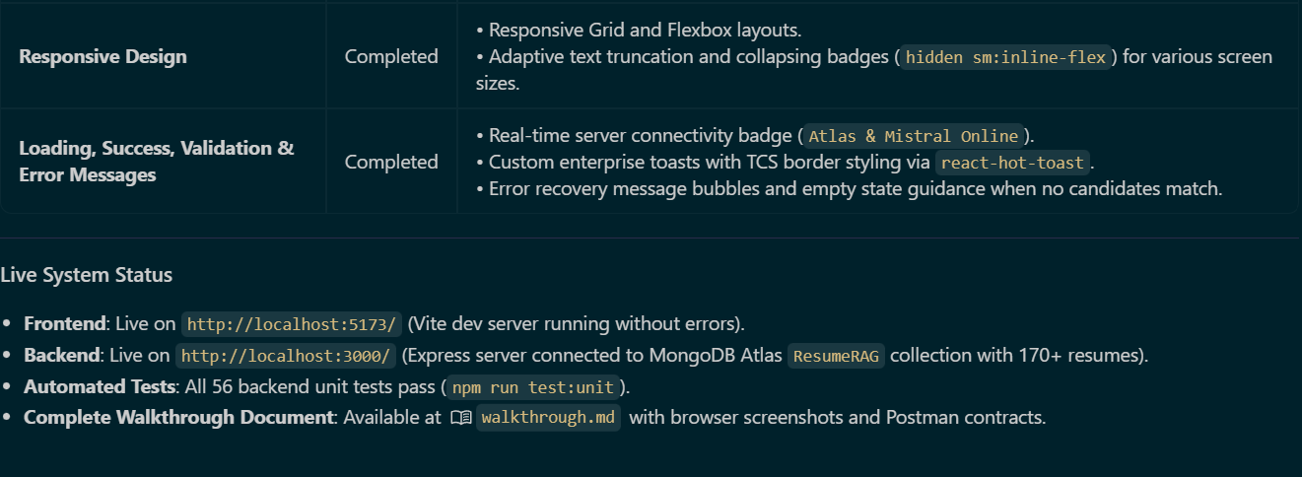
After completing the implementation, test the complete end-to-end application.
Submit the following items in both the WhatsApp group and your GitHub repository:
- Phase-wise implementation file (check main folder)
- Prompt file (check main folder)
- Screenshots of the application and final results (check screenshot folder)
- GitHub repository link - Upload files · reka127-sudo/genai-assignments (phase-2/week-6)
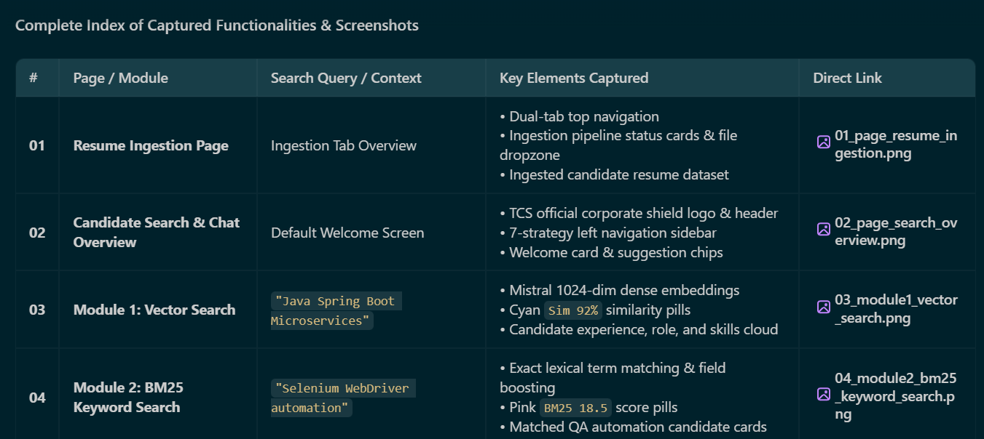
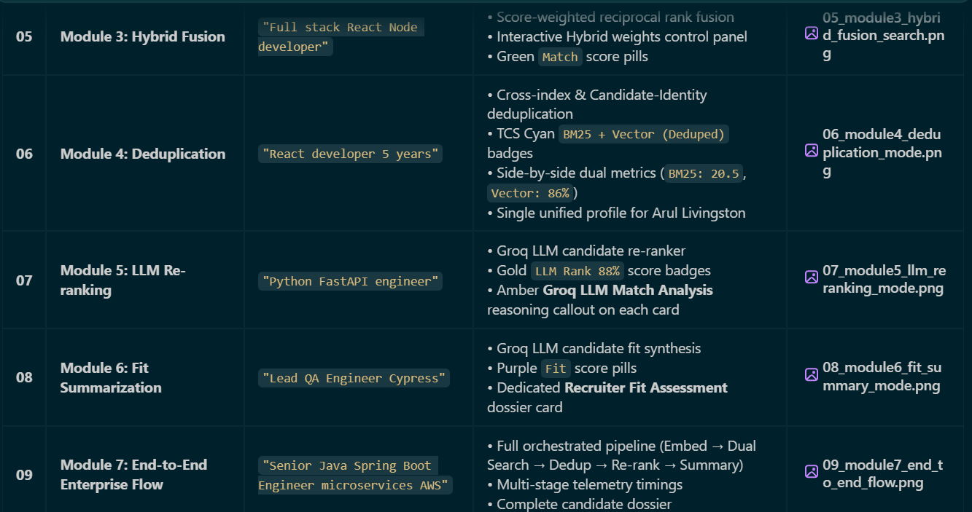
---xx--

